**SVG Images Color set On Mouse Click**

We know that Document Object Model (DOM) has provided a logical structure which ilike a tree. The Document Object Model originated as a specification to allow JavaScript scripts to be portable among web browsers.

XML TREE:

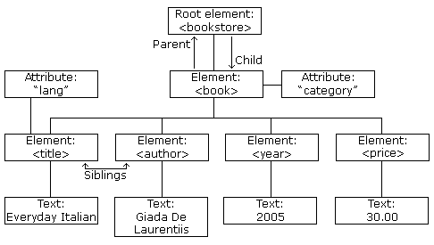

I was worried that how can set the any color to any given image, finally I had found the SVG type of image to be set the color, the one interesting things is SVG images. SVG image is not a convas image type, it is a XML-based Vector image format, we know that XML has DOM struncture, so svg has an enough DOM structure,

SVG FORMAT:

<?xml version="1.0" standalone="no"?>

<svg width="5cm" height="4cm" version="1.1"

xmlns="http://www.w3.org/2000/svg">

<desc>Four separate rectangles

</desc>

<rect x="0.5cm" y="0.5cm" width="2cm" height="1cm"/>

<rect x="0.5cm" y="2cm" width="1cm" height="1.5cm"/>

<rect x="3cm" y="0.5cm" width="1.5cm" height="2cm"/>

<rect x="3.5cm" y="3cm" width="1cm" height="0.5cm"/>

<!-- Show outline of viewport using 'rect' element -->

<rect x=".01cm" y=".01cm" width="4.98cm" height="3.98cm"

fill="none" stroke="blue" stroke-width=".02cm" />

</svg>

Now let’s see how can Javascripts DOM takes a logical tree structure form SVG files.

1. shoud be DOMParser the SVG first,

2. get the parrant node

3. get the childs nodes

4. detect current node name

var parser = new DOMParser();

var doc = parser.parseFromString(stringContainingXMLSource, "image/svg+xml");

x = doc.documentElement.childNodes;

for (i = 0; i < x.length ;i++) {

txt += x[i].nodeName + ": " + x[i].childNodes[0].nodeValue ;

}

then, the important thing is color set to all different nodes with different colors, SVG has many nodes like, path,rect, circle, line etc. Each nodes has their attributes like fill, stroke, width, height etc.

**Color Set:**

Cick to a any area of the SVG image, and check the current node, then select the desired color form color picker and set attribute “fill” (fill=”red”) using Javascripts DOM.Here I have mention attribute “fill” becouse fill attribute is color attribute to set the color of nodes.

function changeColor(evt) {

var SvgNode=evt.target;

SvgNode.setAttribute ('fill', "red");

}



Now Anjoy, Thanks.